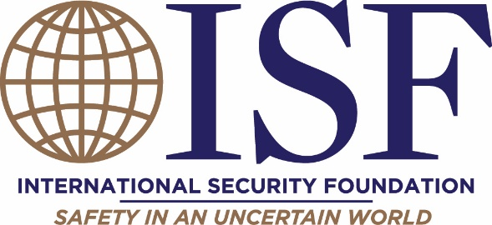

2022 Annual OSAC Council Membership Dues
INVOICE

- $2,500 Executive Member
- $2,000 Strategic Member
- $1,500 Supporting Member
Membership dues are used to fund OSAC Council expenses for the various conferences, meetings and events throughout the year.

Credit card payments can be made online:
http://isf4osac.org/annual-membership-dues/

Please make checks payable to:
International Security Foundation
P.O. Box 523
North Chatham, MA 02650

To make payment by EFT:
Rockland Trust
Acct#7906001941
Routing # for domestic ACH deposits: 011304478
Routing # for international wire transfers: 011304478
SWIFT Code: RTCOUS33

Bank address:
Rockland Trust
288 Union Street
Rockland, MA 02370

If you have any questions, please contact:
Peggy O’Neill, ISF Executive Director, peggyoneill@isf4osac.org, 832-543-1442

ISF is a 501(c)(3) organization. EIN: 80-0719130

